DISORDERS OF BLOOD VESSELS
Disorders of Arteries, Hypertension, Disorders of Veins and Lymphatics.

ARTERIES
The blood vessels are closed circuits for the transport of blood from the left heart to the metabolising cells, and then back to the right heart.
ARTERIES
NORMAL STRUCTURE
Depending upon the calibre and histologic features, arteries are divided into 3 types: large (elastic) arteries, medium-sized (muscular) arteries and the smallest arterioles.
Histologically, arteries of the body have 3 layers in their walls: the tunica intima, the tunica media and the tunica adventitia. These layers progressively decrease with diminution in the size of the vessels.
1. Tunica intima. This is the inner coat of the artery. It is composed of the lining endothelium, subendothelial connective tissue and bounded externally by internal elastic lamina.
Endothelium is a layer of flattened cells adjacent to the flowing blood. The integrity of the endothelial layer is of paramount importance in maintenance of vascular functions since damage to it is the most important event in the initiation of thrombus formation at the site.
2. Tunica media. Is the middle coat of the arterial wall, bounded internally by internal elastic lamina and externally by external elastic lamina. This layer is the thickest and consists mainly of smooth muscle cells and elastic fibres.
3. Tunica adventitia. This is the outer coat of arteries. It consists of loose mesh of connective tissue and some elastic fibres that merge with the adjacent tissues. This layer is rich in lymphatics and autonomic nerve fibres.
There are structural variations in the three types of arteries:
-Large, elastic arteries such as the aorta, innominate, common carotid, major pulmonary, and common iliac arteries have very high content of elastic tissue in the media and thick elastic laminae and hence the name.
-Medium-sized, muscular arteries are the branches of elastic arteries. All the three layers of arterial wall are thinner than in the elastic arteries. The internal elastic lamina appears as a single wavy line while the external elastic lamina is less prominent. The media primarily consists of smooth muscle cells and some elastic fibres (Fig. 15.1).
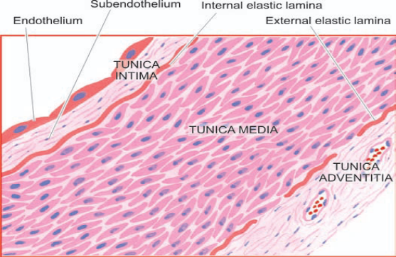
Figure 15.1 The structure of a medium-sized muscular artery.

Arterioles are the smallest branches with internal diameter 20-100 μm. They consist of the three layers as in muscular arteries but are much thinner and cannot be distinguished. The arterioles consist of a layer of endothelial cells in the intima, smooth muscle cells in the media and collagen and elastic tissue comprising the adventitia.
Capillaries are the size of an RBC (7-8 μm) and have a layer of endothelium but no media. Blood from capillaries returns to the heart via post-capillary venules and then into venules and veins.

ARTERIOSCLEROSIS
Arteriosclerosis is a general term used to include all conditions with thickening and hardening of the arterial walls.
The following morphologic entities are included under arteriosclerosis:
I. Senile arteriosclerosis
II. Hypertensive arteriolosclerosis
III. Mönckeberg’s arteriosclerosis
(Medial calcific sclerosis)
IV. Atherosclerosis
The last-named, atherosclerosis, is the most common and most important form of arteriosclerosis; if not specified, the two terms are used interchangeably with each other.
SENILE ARTERIOSCLEROSIS
Senile arteriosclerosis is the thickening of media and intima of the arteries seen due to aging. The changes are nonselective and affect most of the arteries. These are possibly induced by stress and strain on vessel wall during life.
MORPHOLOGIC FEATURES. The changes are as under:
1. Fibroelastosis: The intima and media are thickened due to increase in elastic and collagen tissue.
2. Elastic reduplication: The internal elastic lamina is split or reduplicated so that two wavy layers are seen. Eventually, the fibrotic changes result in age-related elevation of systolic blood pressure.
HYPERTENSIVE ARTERIOLOSCLEROSIS
Hypertension is the term used to describe an elevation in blood pressure. Arteriolosclerosis is the term used to describe 3 morphologic forms of vascular disease affecting arterioles and small muscular arteries. These are: hyaline arteriolosclerosis, hyperplastic arteriolosclerosis and necrotising arteriolitis. All the three types are common in hypertension but may occur due to other causes as well.

Hyaline Arteriolosclerosis
Hyaline sclerosis may be seen physiologically due to aging, or may occur pathologically in benign nephrosclerosis in hypertensives and as a part of microangiopathy in diabetics.
MORPHOLOGIC CHANGES. The visceral arterioles are involved. The vascular walls are thickened and the lumina narrowed or even obliterated. Microscopically, the thickened vessel wall shows structureless, eosinophilic, hyaline material in the intima and media.
PATHOGENESIS. The exact pathogenesis is not known. However, the following hypotheses have been proposed:
i) The lesions result probably from leakage of components of plasma across the vascular endothelium. The permeability of the vessel wall is increased, due to haemodyanamic stress in hypertension and metabolic stress in diabetes, so that these plasma components leak out and get deposited in the vessel wall.
ii) The lesions may be due to immunologic reaction.
iii) Normal aging process that is exaggerated in hypertension and diabetes mellitus.
Hyperplastic Arteriolosclerosis
Is a characteristic lesion of malignant hypertension; other causes include toxaemia of pregnancy.
MORPHOLOGIC FEATURES affect mainly the intima, Three types of intimal thickening may occur.
i) Onion-skin lesion consists of loosely-placed concentric layers of hyperplastic intimal smooth muscle cells like the bulb of an onion.
ii) Mucinous intimal thickening is the deposition of amorphous ground substance.
iii) Fibrous intimal thickening less common and consists of bundles of collagen, elastic fibres and hyaline deposits in the intima.

PATHOGENESIS. The pathogenesis of hyperplastic intimal thickening is unclear. Probably, the changes result following endothelial injury from systemic hypertension, hypoxia or immunologic damage leading to increased permeability. A healing reaction occurs in the form of proliferation of smooth muscle cells with fibrosis.
Necrotising Arteriolitis
In cases of severe hypertension and malignant hypertension, parts of small arteries and arterioles show changes of hyaline sclerosis and parts of these show necrosis,
MORPHOLOGIC FEATURES. Besides the changes of hyaline sclerosis, the changes of necrotising arteriolitis include fibrinoid necrosis of vessel wall, acute inflammatory infiltrate of neutrophils in the adventitia.
PATHOGENESIS. Since necrotising arteriolitis occurs in vessels in which there is sudden and great elevation of pressure, the changes are said to result from direct physical injury to the vessel wall.

MÖNCKEBERG’S ARTERIOSCLEROSIS (MEDIAL CALCIFIC SCLEROSIS)
Mönckeberg’s arteriosclerosis is calcification of the media of large and medium-sized muscular arteries, especially of the extremities and of the genital tract, in persons past the age of 50. The condition occurs as an age-related degenerative process.
MORPHOLOGIC FEATURES. Medial calcification is often an incidental finding in X-rays of the affected sites having muscular arteries. The deposition of calcium salts in the media produces pipestem-like rigid tubes without causing narrowing of the lumen. Microscopically, Mönckeberg’s arteriosclerosis is characterised by deposits of calcium salts in the media.
PATHOGENESIS is considered as an age-related physiologic change due to prolonged effect of vasoconstriction.

ATHEROSCLEROSIS
Definition
Atherosclerosis is a specific form of arteriosclerosis affecting primarily the intima of large and medium-sized muscular arteries and is characterised by fibrofatty plaques or atheromas. The term atherosclerosis is derived from athero- (meaning porridge) referring to the soft lipid-rich material in the centre of atheroma, and sclerosis (scarring) referring to connective tissue in the plaques.
Any large and medium-sized artery may be involved in atherosclerosis, the most commonly affected are the aorta, the coronary and the cerebral arterial systems. Therefore, the major clinical syndromes resulting from ischaemia due to atherosclerosis pertain to the heart (angina and myocardial infarcts or heart attacks), and the brain (transient cerebral ischaemia and cerebral infarcts or strokes); other sequelae are peripheral vascular disease, aneurysmal dilatation, chronic ischaemic heart disease, ischaemic encephalopathy and mesenteric arterial occlusion.
Etiology
The incidences for atherosclerosis are based on the major clinical syndromes produced by it, the most important interpretation being that death from myocardial infarction is related to underlying atherosclerosis. Cardiovascular disease, mostly related to atherosclerotic coronary heart disease or ischaemic heart disease (IHD) is the most common cause of premature death. Risk factors associated with increased risk of developing clinical atherosclerosis, act in combination rather than singly. Risk factors are divided into two groups (Table 15.1):
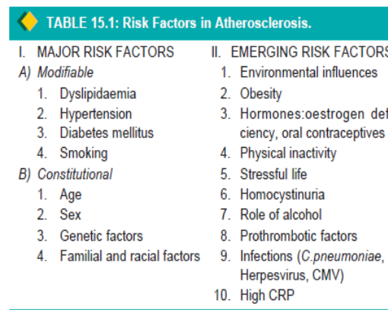
I. Major risk factors. These are further considered under 2 headings:
A) Major risk factors modifiable by life style and/or therapy: dyslipidaemias, hypertension, diabetes mellitus and smoking.
B) Constitutional risk factors: These are non-modifiable major risk factors that include: increasing age, male sex, genetic abnormalities, and familial and racial predisposition.
II. Non-traditional emerging risk factors. This includes factors whose role in atherosclerosis is minimal. A combination of etiologic risk factors have additive effect in producing the lesions of atherosclerosis.

MAJOR RISK FACTORS; MODIFIABLE BY LIFE STYLE AND/OR THERAPY
1. DYSLIPIDAEMIAS. Virchow in 19th century first identified cholesterol crystals in the atherosclerotic lesions. It has been established that hypercholesterolaemia has direct proportionate relationship with atherosclerosis and IHD. The following evidences are cited in support of this:
i) The atherosclerotic plaques contain cholesterol and cholesterol esters, largely derived from the lipoproteins in the blood.
ii) The lesions of atherosclerosis can be induced in experimental animals by feeding them with diet rich in cholesterol.
iii) Individuals with hypercholesterolaemia due to various causes such as in DM, myxoedema and familial hypercholesterolaemia have increased risk of developing atherosclerosis and IHD.
iv) Populations having hypercholesterolaemia have higher mortality from IHD.

The lipoproteins are divided into classes according to the density of solvent in which they remain suspended on centrifugation at high speed. The major classes of lipoprotein particles are chylomicrons, very-low density lipoproteins (VLDL), low-density lipoproteins (LDL), and high-density lipoproteins (HDL). The major fractions of lipoproteins tested in blood lipid profile and their varying effects on atherosclerosis and IHD are as under (Table 15.2):
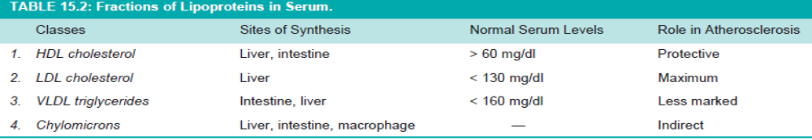
i) Total cholesterol: Normal serum level is 140-200 mg/dl, while levels of borderline high are considered between 200-240 mg/dl. An elevation of total serum cholesterol levels above 260 mg/dl in men and women between 30 and 50 years of age has three times higher risk of developing IHD as compared with people with total serum cholesterol levels within normal limits.
ii) Triglycerides: Normal serum level is below 160 mg/dl.
iii) Low-density lipoproteins (LDL) cholesterol: Normal optimal serum level is <130 mg/dl. LDL is richest in cholesterol and has the maximum association with atherosclerosis.
iv) Very-low-density lipoprotein (VLDL): VLDL carries much of the triglycerides. VLDL has less marked effect than LDL.
v) High-density lipoproteins (HDL) cholesterol: Normal desirable serum level is <60 mg/dl. HDL is protective (‘good cholesterol’) against atherosclerosis.
2. HYPERTENSION. Is a risk factor for all clinical manifestations of atherosclerosis. It doubles the risk of all forms of cardiovascular disease. It acts by mechanical injury to the arterial wall due to increased blood pressure. Elevation of systolic pressure of over 160 mmHg or a diastolic pressure of over 95 mmHg is associated with five times higher risk of developing IHD than in people with blood pressure within normal range (140/90 mmHg or less).
3. SMOKING. Is associated with higher risk of atherosclerotic IHD and sudden cardiac death. Men who smoke a pack of cigarettes a day are 3-5 times more likely to die of IHD than non-smokers. The increased risk and severity of atherosclerosis in smokers is due to reduced level of HDL, deranged coagulation system and accumulation of carbon monoxide in blood that produces carboxyhaemoglobin and eventually hypoxia in the arterial wall favouring atherosclerosis.
4. DIABETES MELLITUS. Clinical manifestations of atherosclerosis develop at an early age in people with both type 1 and type 2 diabetes mellitus. In particular, association of type 2 diabetes mellitus characterised by metabolic (insulin resistance) syndrome and abnormal lipid profile termed ‘diabetic dyslipidaemia’ is common and heightens the risk of cardiovascular disease.
CONSTITUTIONAL RISK FACTORS
1. AGE. Atherosclerosis is an age-related disease, clinically significant lesions are found with increasing age. Fully-developed atheromatous plaques appear in the 4th decade and beyond.
2. SEX. The incidence and severity of atherosclerosis are more in men than in women and the changes appear a decade earlier in men (>45 years) than in women (>55 years). The prevalence of atherosclerotic IHD is about three times higher in men in 4th decade than in women.The lower incidence of IHD in women, especially in premenopausal age, is due to high levels of oestrogen and high-density lipoproteins, both of which have anti-atherogenic influence.
3. GENETIC FACTORS Hereditary genetic derangements of lipoprotein metabolism predispose the individual to high blood lipid level and familial hypercholesterolaemia.
4. FAMILIAL FACTORS: Familial predisposition to atherosclerosis may be related to other risk factors like diabetes, hypertension and hyperlipoproteinaemia.
EMERGING RISK FACTORS
Nontraditional newly emerging risk factors for which the role in the etiology of atherosclerosis is yet not fully supported. These factors are as under:
1. Higher incidence of atherosclerosis in developed countries and low prevalence in underdeveloped countries, suggesting the role of environmental influences.
2. Obesity, if the person is overweight by 20% or more, is associated with increased risk.
3. Use of exogenous hormones (e.g. oral contraceptives) by women or endogenous oestrogen deficiency (e.g. in postmenopausal women) has been shown to have an increased risk of developing myocardial infarction or stroke.
4. Physical inactivity and lack of exercise .
5. Stressful life style, termed as ‘type A’ behaviour pattern, characterised by aggressiveness, ambitiousness, is associated with enhanced risk of IHD compared with ‘type B’ behaviour of relaxed type.
6. Moderate consumption of alcohol has slightly beneficial effect by raising the level of HDL cholesterol.
7. Prothrombotic factors and elevated fibrinogen levels favour formation of thromb.
8. Role of infections, particularly of Chlamydia pneumoniae and viruses such as herpes virus and cytomegalovirus, has been found in coronary atherosclerotic lesions .
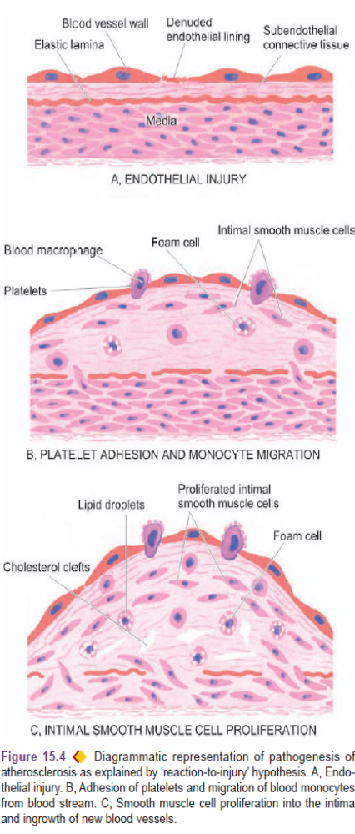
9. Markers of inflammation such as elevated C reactive protein, an acute phase reactant, correlate with risk of developing atherosclerosis.

Pathogenesis
Atherosclerosis is a multifactorial process. A number of theories have been proposed.
Insudation hypothesis. The concept hypothesised by Virchow in 1856 that atherosclerosis is a form of cellular proliferation of the intimal cells resulting from increased imbibing of lipids from the blood came to be called the ‘lipid theory’.
Encrustation hypothesis. The proposal put forth by Rokitansky in 1852 that atheroma represented a form of encrustation on the arterial wall from the components in the blood forming thrombi composed of platelets, fibrin and leucocytes.The components of thrombus (platelets, fibrin and leucocytes) have a role in atheromatous lesions.
There four key factors involved in atherosclerosis—arterial smooth muscle cells, endothelial cells, blood monocytes and dyslipidaemia. The pathogenesis of atherosclerosis is explained on the basis of the following two theories:
1. Reaction-to-injury hypothesis, first described in 1973, and modified in 1986 and 1993 by Ross.
2. Monoclonal theory, based on neoplastic proliferation of smooth muscle cells, postulated by Benditt and Benditt in 1973.
1. REACTION-TO-INJURY HYPOTHESIS. This theory is most widely accepted and incorporates aspects of two older historical theories of atherosclerosis—the lipid theory of Virchow and thrombogenic (encrustation) theory of Rokitansky.
The following is the accepted role of key components involved in atherogenesis, diagrammatically illustrated in Fig. 15.4.

i) Endothelial injury is the initial triggering event in the development of lesions of atherosclerosis. Endothelial dysfunction may initiate the sequence of events.Two of the major risk factors which act together to produce endothelial injury are: haemodynamic stress from hypertension and chronic dyslipidaemia..
ii) Intimal smooth muscle cell proliferation. Endothelial injury causes adherence, aggregation and platelet release reaction at the site of exposed subendothelial connective tissue and infiltration by inflammatory cells. Proliferation of intimal smooth muscle cell and production of extracellular matrix are stimulated by cytokines such as IL-1 and TNF-α and by activated platelets at the site of endothelial injury. These cytokines lead to local synthesis of following growth factors having distinct roles in plaque evolution:
Platelet-derived growth factor (PDGF) and fibroblast growth factor (FGF) stimulate proliferation and migration of smooth muscle cells from their usual location in the media into the intima.
iii) Role of blood monocytes. LDL does appear in the monocyte cytoplasm to form foam cell. Plasma LDL on entry into the intima undergoes oxidation. The ‘oxidised LDL’ formed in the intima performs the following functions on monocytes and endothelium:
-For monocytes: Oxidised LDL acts to attract, proliferate, immobilise and activate them and are taken up by scavenger receptor on the monocyte to transform it to a lipid-laden foam cell.
-For endothelium: Oxidised LDL is cytotoxic. Death of foam cell by apoptosis releases lipid to form lipid core of plaque.
iv) Role of dyslipidaemia chronic dyslipidaemia in itself may initiate endothelial injury and dysfunction by causing increased permeability. Hypercholesterolaemia with increased serum concentration of LDL promotes formation of foam cells, while high serum concentration of HDL has anti-atherogenic effect.
v) Thrombosis. Endothelial injury exposes subendothelial connective tissue resulting in formation of small platelet aggregates at the site and causing proliferation of smooth muscle cells. This causes mild inflammatory reaction which together with foam cells is incorporated into the atheromatous plaque. The lesions enlarge by attaching fibrin and cells from the blood so that thrombus becomes a part of atheromatous plaque.
2. MONOCLONAL HYPOTHESIS. Is based on the postulate that proliferation of smooth muscle cells is the primary event and that this proliferation is monoclonal in origin. The evidence cited in support of monoclonal hypothesis is the observation on proliferated smooth muscle cells in atheromatous plaques.
MORPHOLOGIC FEATURES
Early lesions in the form of diffuse intimal thickening, fatty streaks and gelatinous lesions are the forerunners in the evolution of atherosclerotic lesions. However, the clinical disease states due to luminal narrowing in atherosclerosis are caused by fully developed Atheromatous plaques and complicated plaques (Fig. 15.6).
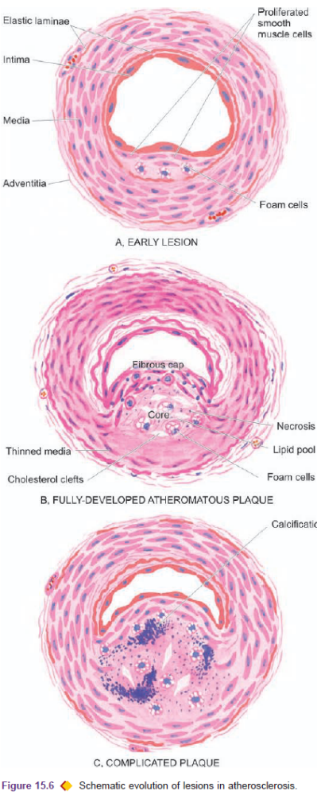
1.FATTY STREAKS AND DOTS. Fatty streaks and dots on the intima may be the precursor lesions of atheromatous plaques. They are prominent in the aorta and other major arteries, more on the posterior wall than the anterior wall.
Grossly, the lesions may appear as flat or slightly elevated and yellow. They may be either in the form of small, multiple dots, about 1 mm in size, or in the form of elongated, beaded streaks.
2. GELATINOUS LESIONS, develop in the intima of the aorta and other major arteries in the first few months of life. They may also be precursors of plaques. They are circumscribed grey elevations, about 1 cm in diameter.
3. ATHEROMATOUS PLAQUES. A fully developed atherosclerotic lesion is called atheromatous plaque, also called fibrous plaque, or atheroma. Most often and most severely affected is the abdominal aorta, smaller lesions may be seen in descending thoracic aorta and aortic arch. The major branches of the aorta around the ostia especially the iliac, femoral, carotid, coronary, and cerebral arteries.
Grossly, atheromatous plaques are white to yellowish lesions, from 1-2 cm in diameters.Cut section of the plaque reveals the luminal surface as a firm, white fibrous cap and a central core.
Microscopically, the appearance of plaque varies depending upon the age of the lesion.
Cellular area under the fibrous cap is comprised by a mixture of macrophages, foam cells, lymphocytes and smooth muscle cells which may contain lipid. Deeper central soft core consists of extracellular lipid material, cholesterol clefts, and lipid laden foam cells. In older and more advanced lesions, the collagen in the fibrous cap may be dense and hyalinised, smooth muscle cells may be atrophic.
4. COMPLICATED PLAQUES. Pathologic changes that occur in fully-developed atheromatous plaques are called the complicated lesions. These changes include calcification, ulceration, thrombosis, haemorrhage and aneurysmal dilatation.
i) Calcification. Occur in advanced atheromatous plaques, especially in the aorta and coronaries.
ii) Ulceration. The layers covering the soft pultaceous material of an atheroma may ulcerate as a result of haemodynamic forces or mechanical trauma. This results in discharge of emboli composed of lipid material and debris into the blood stream, leaving a shallow, ragged ulcer .
iii) Thrombosis. Ulcerated plaque and areas of endothelial damage are vulnerable sites for formation of superimposed thrombi. Thrombi may get dislodged to become emboli and lodge elsewhere in the circulation, or may get organised and incorporated into the arterial wall as mural thrombi. Mural thrombi may become occlusive thrombi which may subsequently recanalise.
iv) Haemorrhage. Intimal haemorrhage may occur in an atheromatous plaque either from the blood in the vascular lumen or from rupture of thin-walled capillaries that vascularise the atheroma,is a common complication in coronary arteries.
v) Aneurysm formation. Advanced lesions are associated with secondary changes in the media and adventitia. The changes in media include atrophy and thinning of the media and fragmentation of internal elastic lamina. The adventitia undergoes fibrosis. These changes cause weakening in the arterial wall resulting in aneurysmal dilatation.

Clinical Effects
The clinical effects of atherosclerosis depend upon the size and type of arteries affected:
1. Slow luminal narrowing causing ischaemia and atrophy.
2. Sudden luminal occlusion causing infarction necrosis.
3. Propagation of plaque by formation of thrombi and emboli.
4. Formation of aneurysmal dilatation and eventual rupture.

Large arteries affected most are the aorta, renal, mesenteric and carotids, whereas the medium- and smallsized arteries involved are the coronaries, cerebrals and arteries of the lower limbs. Accordingly, the symptomatic atherosclerotic disease involves the heart, brain, kidneys, small intestine and lower extremities:
i) Aorta—Aneurysm formation, thrombosis and embolisation to other organs.
ii) Heart—Myocardial infarction, ischaemic heart disease.
iii) Brain—Chronic ischaemic brain damage, cerebral infarction.
iv) Small intestine—Ischaemic bowel disease, infarction.
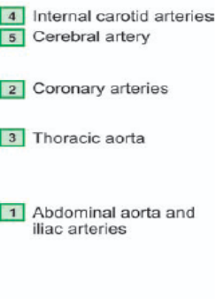
v) Lower extremities—Intermittent claudication, gangrene.
ARTERITIS
Arteritis, angiitis and vasculitis are terms used for inflammatory process in an artery or an arteriole. It may occur following invasion of the vessel by infectious agents, or may be induced by non-infectious injuries such as chemical, mechanical, immunologic and radiation injury. The non-infectious group is more important than the infectious type.
TABLE 15.3: Classification of Vasculitis
I. INFECTIOUS ARTERITIS
1. Endarteritis obliterans
2. Non-syphilitic infective arteritis
3. Syphilitic arteritis
II. NON-INFECTIOUS ARTERITIS
1. Polyarteritis nodosa (PAN)
2. Hypersensitivity (allergic, leucocytoclastic) vasculitis
3. Wegener’s granulomatosis
4. Temporal (giant cell) arteritis
5. Takayasu’s arteritis (pulseless disease)
6. Kawasaki’s disease
7. Buerger’s disease (thromboangiitis obliterans)
8. Miscellaneous Vasculitis

I. INFECTIOUS ARTERITIS
Direct invasion of the artery by infectious agents, especially bacteria and fungi, causes infectious arteritis. It may be found in the vicinity of an infected focus like in tuberculosis, pneumonia, abscesses or from haematogenous spread of infection such as in infective endocarditis, septicaemia.

Endarteritis Obliterans is a non-specific inflammatory response of arteries and arterioles to a variety of irritants. It is seen close to the lesions of peptic ulcers of the stomach and duodenum, tuberculous and chronic abscesses in the lungs, chronic cutaneous ulcers, chronic meningitis, and in post-partum and post-menopausal uterine arteries.

Non-syphilitic Infective Arteritis
Various forms of invasions of the artery by bacteria, fungi, parasites or viruses, either directly or by haematogenous route, cause non-syphilitic infective arteritis.

Syphilitic Arteritis
Syphilitic vascular involvement occurs in all stages of syphilis but is more prominent in the tertiary stage. The changes that are found in the syphilitic arteritis are seen within the arterial tissue (syphilitic endarteritis) and in the periarterial tissues (syphilitic periarteritis). Manifestations are prominent at two sites—the aorta and the cerebral arteries.

SYPHILITIC AORTITIS. Syphilitic involvement of the ascending aorta and the aortic arch is the commonest manifestation of cardiovascular syphilis. It occurs in about 80% cases of tertiary syphilis. Preferential involvement of the arch of aorta may be due to involvement of mediastinal lymph nodes in secondary syphilis through which the treponemes spread to the lymphatics around the aortic arch.
Microscopically, the conspicuous features are:Endarteritis and periarteritis of the vasa vasorum located in the media and adventitia.
The effects of syphilitic aortitis are as follows:
a) Aortic aneurysm may result from damage to the aortic wall.
b) Aortic valvular incompetence results from spread of the syphilitic process to the aortic valve ring.
c) Stenosis of coronary ostia may lead to progressive myocardial fibrosis, angina pectoris and sudden death.
The features distinguishing syphilitic aortitis from aortic atheroma are given in Table 15.4.
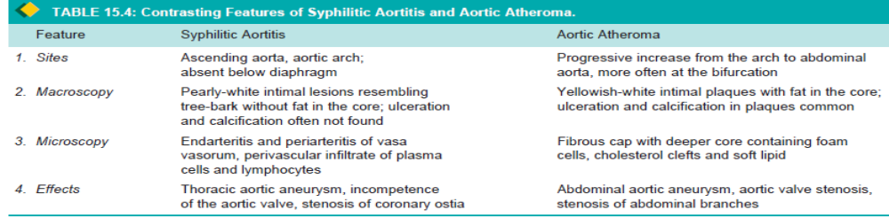

CEREBRAL SYPHILITIC ARTERITIS (HEUBNER’S ARTERITIS). Syphilitic involvement of small and medium sized cerebral arteries occurs during tertiary syphilis. The changes may accompany syphilitic meningitis.
Grossly, the cerebral vessels are white, rigid and thick walled.
MicroscopicallyThere is atrophy of muscle in the media and replacement by fibrosis. This results in ischaemic atrophy of the brain.

II. NON-INFECTIOUS ARTERITIS
This group consists of most of the important forms of vasculitis, more often affecting arterioles, venules and capillaries also termed as small vessel vasculitis. Serum from patients with vasculitis of immunologic origin show the presence of following immunologic features:
1. Anti-neutrophil cytoplasmic antibodies (ANCAs).
Patients with immunologic vasculitis have autoantibodies in their serum against the cytoplasmic antigens of the neutrophils, macrophages and endothelial cells; these are called ANCAs. Neutrophil immunofluorescence is used to demonstrate their presence, of which two distinct patterns of ANCAs are seen: i)Cytoplasmic ANCA (c-ANCA) pattern ii)Perinuclear ANCA (p-ANCA) pattern
2. Anti-endothelial cell antibodies (AECAs). These antibodies are demonstratable in cases of SLE, Kawasaki disease and Buerger’s disease.
3. Pauci-immune vasculitis. There are some cases which do not have immune deposits and are termed as cases of pauci-immune Vasculitis.

Polyarteritis Nodosa
Is a necrotising vasculitis involving small and medium-sized muscular arteries of multiple organs and tissues.The disease occurs more commonly in adult males than females. Affected organs, in descending order of frequency of involvement, are the kidneys, heart, liver, gastrointestinal tract, muscle, pancreas, testes, nervous system and skin.
The syndrome of PAN presents with symptoms pertaining to different organs. Some clinical features are fever, malaise, weight loss, renal manifestations (albuminuria, haematuria and renal injury), vascular lesions in the alimentary tract (abdominal pain and melaena), peripheral neuritis and hypertension. Grossly, the lesions of PAN involve segments of vessels, at the bifurcations and branchings, as tiny beaded nodules.
Microscopically, there are 3 sequential stages in the evolution of lesions in PAN:
i) Acute stage—There is fibrinoid necrosis in the centre of the nodule located in the media. The weakened wall may be the site of aneurysm formation.
ii) Healing stage—Marked fibroblastic proliferation producing firm nodularity.
iii) Healed stage—The affected arterial wall is thickened due to dense fibrosis. Healed stage contains haemosiderin-laden macrophages and organized thrombus.

Hypersensitivity Vasculitis
Also called allergic or leucocytoclastic vasculitis or microscopic polyarteritis, is a group of clinical syndromes differing from PAN in having inflammatory involvement of venules, capillaries and arterioles. The tissues and organs involved are the skin, mucous membranes, lungs, brain, heart, gastrointestinal tract, kidneys and muscle. The condition results from immunologic response to an identifiable antigen that may be bacteria (e.g. streptococci, staphylococci,), viruses (e.g. hepatitis B virus, influenza virus), malarial parasite, drugs and chemicals.
Hypersensitivity vasculitis includes entities such as serum sickness, vasculitis associated with malignancy, and vasculitis associated with connective tissue diseases like rheumatoid arthritis. Microscopically, the lesions involve smallest vessels. Two histologic forms are described:
i) Leucocytoclastic vasculitis, characterised by fibrinoid necrosis with neutrophilic infiltrate in the vessel wall..
ii) Lymphocytic vasculitis, in which the vessel shows infiltration by lymphocytes. This type is seen in vascular injury due to delayed hypersensitivity or cellular immune reactions.

Wegener’s Granulomatosis
Is another form of necrotizing vasculitis characterised by a clinicopathologic triad consisting of the following:
i) Acute necrotising granulomas of the upper and lower respiratory tracts involving nose, sinuses and lungs;
ii) focal necrotising vasculitis, of the lungs and upper airways;
iii) focal or diffuse necrotising glomerulonephritis.
Organs involved are the lungs, paranasal sinuses, nasopharynx and kidneys. Other involved organs are joints, skin, eyes, ears, heart and nervous system. Typical features include pneumonitis with bilateral infiltrates in the lungs, chronic sinusitis, nasopharyngeal ulcerations and renal disease.
.
Histologically, the characteristic feature is the presence of necrotising granulomatous inflammation of the tissues and necrotizing vasculitis with or without granulomas:

Buerger’s Disease (Thromboangiitis Obliterans)
Buerger’s disease is a specific disease entity affecting small and medium-sized arteries and veins of the extremities and characterised by acute and chronic occlusive inflammatory involvement. The disease affects men under the age of 35 years who are heavy cigarette smokers. The symptoms consists of intermittent claudication due to ischaemia manifested by intense pain affecting the limbs commonly the legs. Eventually, gangrene of the affected extremities occurs requiring amputation.
Etiopathogenesis. Association with heavy cigarette smoking. This has led to the hypothesis that tobacco products cause direct endothelial damage leading to hypercoagulability and thrombosis, or is a result of hypersensitivity to tobacco products.
Genetic factors play a role as the disease has familial occurrence and has HLA association. An increased prevalence is seen in individuals with HLA-A9 and HLA-B5 antigens.
Grossly, the lesions are segmental affecting small and medium-sized arteries of the lower extremities..
Microscopically, the following changes are seen in different stages of the disease:
i) In early stage, there is infiltration by polymorphs in all the layers of vessels and presence of mural or occlusive thrombosis of the lumen..
ii) In advanced stage, the cellular infiltrate is predominantly mononuclear and may contain an occasional epithelioid cell granuloma with Langhans’ giant cells.

Raynaud’s Disease and Raynaud’s Phenomenon
Raynaud’s disease is not a vasculitis but is a functional vasospastic disorder affecting chiefly small arteries and arterioles of the extremities, occurring in young healthy females. The disease affects comm the fingers and hands.The ischaemic effect is provoked by cold but other stimuli such as emotions, trauma, hormones and drugs. Clinically, the affected digits show pallor, followed by cyanosis, and then redness, corresponding to arterial ischaemia, venostasis and hyperaemia respectively.The cause of the disease occurs due to vasoconstriction mediated by autonomic stimulation of the affected vessels.

Raynaud’s phenomenon differs from Raynaud’s disease in having an underlying cause e.g. secondary to artherosclerosis, diseases like SLE, Buerger’s disease, multiple myeloma, pulmonary hypertension.
Raynaud’s phenomenon like Raynaud’s disease, also shows cold sensitivity but differs from the latter in having structural abnormalities in the affected vessels.

ANEURYSMS
DEFINITION
Defined as a permanent abnormal dilatation of a blood vessel occurring due to congenital or acquired weakening or destruction of the vessel wall. Aneurysms involve large elastic arteries, especially the aorta and its major branches. Aneurysms cause effects such as thrombosis and thromboembolism, alteration in the flow of blood, rupture of the vessel and compression of neighbouring structures.

CLASSIFICATION
Aneurysms can be classified on the basis of various features:
A. Depending upon the composition of the wall:
1 True aneurysm composed of all the layers of a normal vessel wall.
2. False aneurysm having fibrous wall and occurring from trauma to the vessel.
B. Depending upon the shape: These are as under
(Fig. 15.15):

Figure 15.15 Common shapes of aneurysms of various types.

1. Saccular having large spherical outpouching.
2. Fusiform having slow spindle-shaped dilatation.
3. Cylindrical with a continuous parallel dilatation.
4. Serpentine or varicose which has tortuous dilatation of the vessel.
5. Racemose or circoid having mass of intercommunicating small arteries and veins.
C. Based on pathogenetic mechanisms: This classification is mostly followed (Fig. 15.16):
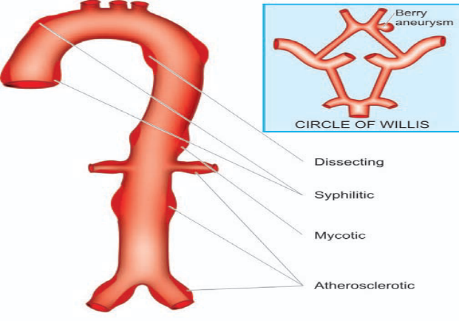
1. Atherosclerotic (arteriosclerotic) aneurysms are the most common type.
2. Syphilitic (luetic) aneurysms found in the tertiary stage of the syphilis.
3. Dissecting aneurysms (Dissecting haematoma) the blood enters the separated or dissected wall of the vessel.
4. Mycotic aneurysms result from weakening of the arterial wall by microbial infection.
5. Berry aneurysms are small dilatations affecting the circle of Willis in the base of the brain.

Atherosclerotic Aneurysms
Are the most common form of aortic aneurysms. Seen commonly in males and the frequency increases after the age of 50 years when the incidence of complicated lesions of advanced atherosclerosis is higher. They are most common in the abdominal aorta. Other locations include thoracic aorta (essentially the ascending part and arch of aorta), iliac arteries and other large systemic arteries.
PATHOGENESIS. Severe atherosclerotic lesions cause thinning and destruction of the medial elastic tissue resulting in atrophy and weakening of the wall. Since atherosclerotic lesions are most common and severe in the abdominal aorta, atherosclerotic aneurysms frequently occur here.
MORPHOLOGIC FEATURES. Atherosclerotic aneurysms of the abdominal aorta are most frequently infrarenal, above the bifurcation of the aorta but may extend into common iliac arteries. Atherosclerotic aneurysm is mostly fusiform in shape.and contains mural thrombus.
Histologically, the wall of atherosclerotic aneurysm loses its normal arterial structure. Instead, there is predominance of fibrous tissue in the media and adventitia with mild chronic inflammatory reaction. EFFECTS. Clinical effects of atherosclerotic aneurysms are due to complications:
1. Rupture of the atherosclerotic aneurysm is the most serious and fatal complication. The risk of rupture depends upon the size and duration of the aneurysm and the blood pressure. Rupture of abdominal aneurysm may occur either into the peritoneum or into the retroperitoneum resulting in sudden and massive bleeding.
2. Compression. The atherosclerotic aneurysm may press upon some adjacent structures such as compression of ureter and erosion on the vertebral bodies.
3. Arterial occlusion. Atherosclerotic aneurysms of the abdominal aorta may occlude the inferior mesenteric artery, or there may be development of occlusive thrombosis.

Syphilitic (Luetic) Aneurysms
Cardiovascular syphilis occurs in about 10% cases of syphilis. It causes arteritis—syphilitic aortitis and cerebral arteritis. It usually manifests after the age of 50 years and is more common in men. The predominant site of involvement is the thoracic aorta, especially in the ascending part and arch of aorta. PATHOGENESIS. About 40% cases of syphilitic aortitis develop syphilitic aneurysms. The process begins from inflammatory infiltrate around the vasa vasorum of the adventitia, followed by endarteritis obliterans. This results in ischaemic injury to the media causing destruction of the smooth muscle and elastic tissue of the media and scarring.
MORPHOLOGIC FEATURES. Syphilitic aneurysms occurring in the ascending part and the arch of aorta are saccular in shape and 3-5 cm in diameter. The intimal surface is wrinkled and shows tree-bark appearance.
EFFECTS. The clinical manifestations are found much more frequently in syphilitic aneurysms than in atherosclerotic aneurysms. The effects include the following:
1. Rupture. Syphilitic aneurysm is likely to rupture causing massive and fatal haemorrhage into the pleural cavity, pericardial sac, trachea and oesophagus.
2. Compression. The aneurysm may press on the adjacent tissues and cause symptoms such as on trachea causing dyspnoea, on oesophagus causing dysphagia, on recurrent laryngeal nerve leading to hoarseness; and erosion of vertebrae, sternum and ribs due to persistent pressure.
3. Cardiac dysfunction. When the aortic root and valve are involved, syphilitic aneurysm produces aortic incompetence and cardiac failure.

Dissecting Aneurysms and Cystic Medial Necrosis
This term is applied for a dissecting haematoma in which the blood enters the separated (dissected) wall of the vessel and spreads for varying distance longitudinally. The most common site is the aorta.The condition occurs commonly in men in the age range of 50 to 70 years. In women, dissecting aneurysms may occur during pregnancy.
PATHOGENESIS. The pathogenesis of dissecting aneurysm is explained on the basis of weakened aortic media. Various conditions causing weakening in the aortic wall resulting in dissection are as under:
i) Hypertensive state. About 90% cases of dissecting aneurysm have hypertension .
ii) Non-hypertensive cases. Occur in cases having local or systemic connective tissue disorder e.g.
a) Marfan’s syndrome, an autosomal dominant disease with genetic defect in fibrillin which is a connective tissue protein required for elastic tissue formation.
b) Development of cystic medial necrosis of Erdheim, especially in old age.
c) Iatrogenic trauma during cardiac catheterisation or coronary bypass surgery.
d) Pregnancy.

Two classification schemes for dissections of thoracic aorta and intramural haematoma have been described
I. DeBakey classification. Depending upon the extent of aortic dissection, three types are described:
Type I: Comprises 75% of cases; the intimal tear begins in the ascending aorta but dissection extends distally for some distance.
Type II: Comprises 5% of cases and dissection is limited to the ascending aorta.
Type III: Constitutes the remaining 20% cases. In these cases, intimal tear begins in the descending thoracic aorta near the origin of subclavian artery and dissection extends distally.
II. Stanford classification. Depending upon clinical management, these are divided into 2 types:
Type A (Proximal dissection): Involves the ascending aorta and includes type I and II of the above scheme.
Type B (Distal dissection): Limited to descending aorta and sparing the ascending aorta; it corresponds to DeBakey type III.
EFFECTS. The classical clinical manifestation of a dissecting aneurysm is excruciating tearing pain in the chest moving downwards. The complications arising from dissecting aneurysms are as under:
1. Rupture. Haemorrhage from rupture of a dissecting aneurysm in the ascending aorta results in mortality in 90% of cases. Most haemorrhage occurs into the pericardium; less frequently it may rupture into thoracic cavity, abdominal cavity or retroperitoneum.
2. Cardiac disease. Involvement of the aortic valve results in aortic incompetence. Obstruction of coronaries results in ischaemia causing fatal myocardial infarction.
3. Ischaemia. Obstruction of the branches of aorta by dissection results in ischaemia of the tissue supplied. There may be renal infarction, cerebral ischaemia and infarction of the spinal cord.

HYPERTENSIVE VASCULAR DISEASE
A persistent and sustained high blood pressure has damaging effects on the heart (e.g. hypertensive heart disease), brain (e.g. cerebrovascular accident or stroke) and kidneys (benign and malignant nephrosclerosis).
Definition and Classification
Hypertension accounts for 6% of death worldwide. Epidemiologic studies have revealed that with elevation in systolic and diastolic blood pressure above normal in adults, there is a continuous increased risk of cardiovascular disease, stroke and renal disease—cardiovascular risk doubles with every 20 mmHg increase in systolic and 10 mmHg increase in diastolic blood pressure above normal levels. Criteria for normal blood pressure, prehypertension and hypertension (stage 1 and stage 2) have been laid by the National Institutes of Health (NIH), US (Table 22.14).
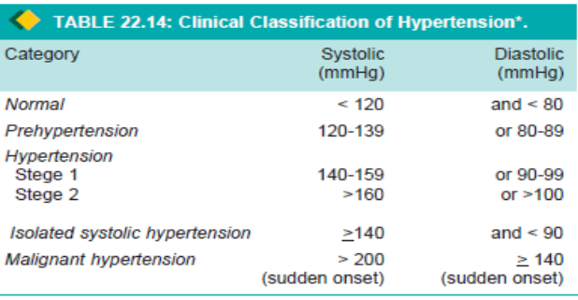
According to this criteria, normal cut-off values for systolic and diastolic blood pressure are taken as < 120 and < 80 mmHg respectively. As per this criteria, arterial or systemic hypertension in adults is defined clinically as persistently elevated systolic blood pressure of 140-159 mmHg, or diastolic pressure of 90-99 mmHg as stage 1 hypertension, and corresponding values above 160 or above 100 mmHg as stage 2 hypertension. The diastolic pressure is considered more significant. Hypertension is classified into 2 types:
1. Primary or essential hypertension in which the cause of increase in blood pressure is unknown. Essential hypertension constitutes about 80-95% patients of hypertension.
2. Secondary hypertension, in which the increase in blood pressure is caused by diseases of the kidneys, endocrines or some other organs. Secondary hypertension comprises remaining 5-20% cases of hypertension. Both essential and secondary hypertension may be benign or malignant.
Benign hypertension is moderate elevation of blood pressure and the rise is slow over the years. About 90-95% patients of hypertension have benign hypertension.
Malignant hypertension is marked and sudden increase of blood pressure to 200/140 mmHg or more in a known case of hypertension or in a previously normotensive individual; the patients develop papilloedema, retinal haemorrhages and hypertensive encephalopathy. Less than 5% of hypertensive patients develop malignant hypertension and life expectancy after diagnosis in these patients is less than 2 years if not treated effectively.

Etiology and Pathogenesis
The mechanism of essential hypertension that constitutes about 90% of cases remains obscure. Normal blood pressure is regulated by 2 haemodynamic forces—cardiac output and total peripheral vascular resistance. Factors which alter these two factors result in hypertension..
ESSENTIAL (PRIMARY) HYPERTENSION. By definition, the cause of essential hypertension is unknown but a number of factors are related to its development. These are as under:
1. Genetic factors. The evidences in support are the familial aggregation, occurrence of hypertension in twins, epidemiologic data and identification of hypertension susceptibility gene (angiotensinogen gene).
2. Racial and environmental factors. implicated in the development of hypertension include salt intake, obesity, skilled occupation, higher living standards and individuals under high stress.
3. Risk factors modifying the course of essential hypertension.
There is sufficient evidence to show that the course of essential hypertension that begins in middle life is modified by a number of factors. These are as under:
i) Age. Younger the age at which hypertension is first noted but left untreated, lower the life expectancy.
ii) Sex. Females with hypertension appear to do better than males.
iii) Atherosclerosis. Accelerated atherosclerosis invariably accompanies essential hypertension, due to contributory role of other independent factors like cigarette smoking, elevated serum cholesterol, glucose intolerance and obesity.
iv) Other risk factors. which alter the prognosis in hypertension include: smoking, excess of alcohol intake, diabetes mellitus, persistently high diastolic pressure above normal and evidence of end-organ damage (i.e. heart, eyes, kidney and nervous system).
The pathogenetic mechanism in essential hypertension is explained by many theories. These are as under:
1. High plasma level of catecholamines.
2. Increase in blood volume i.e. arterial overfilling (volume hypertension) and arteriolar constriction (vasoconstrictor hypertension).
3. Increased cardiac output.
4. Low-renin essential hypertension found in approximately 20% patients due to altered responsiveness to renin release.
5. High renin essential hypertension seen due to decreased adrenal responsiveness to angiotensin II.

SECONDARY HYPERTENSION.
Less common than essential hypertension, mechanisms underlying secondary hypertension with identifiable cause have been studied more extensively. Based on the etiology, these are described under four headings: renal hypertension, endocrine hypertension, hypertension associated with coarctation of aorta and neurogenic causes.
1. RENAL HYPERTENSION. Hypertension produced by renal diseases is called renal hypertension, subdivided into 2 groups:
i) Renal vascular hypertension e.g. in occlusion of a major renal artery, pre-eclampsia, eclampsia, polyarteritis nodosa and fibromuscular dysplasia of renal artery.
ii) Renal parenchymal hypertension e.g. in types of glomerulonephritis, pyelonephritis, diabetic nephropathy, polycystic kidney disease and renin-producing tumours. In either case, renal hypertension can be produced by one of the following 3 inter-related pathogenetic mechanisms:
a) Activation of renin-angiotensin system. Renin is a proteolytic enzyme produced and stored in the granules of the juxtaglomerular cells surrounding the afferent arterioles of glomerulus.The release of renin is stimulated by renal ischaemia, sympathetic nervous system stimulation, depressed sodium concentration, fluid depletion and decreased potassium intake. Released renin is transported through blood stream to the liver where it acts upon substrate angiotensinogen, an α2-globulin synthesised in the liver, to form angiotensin I. Angiotensin I is converted into angiotensin II, by the action of convertase in the lungs. Angiotensin II is the most potent occurring vasoconstrictor.
The other main effect of angiotensin II is to stimulate the adrenal cortex to secrete aldosterone that promotes reabsorption of sodium and water. Thus, the renin-angiotensin system is concerned mainly with 3 functions:
i) Control of blood pressure by altering plasma concentration of angiotensin II and aldosterone.
ii) Regulation of sodium and water content.
iii) Regulation of potassium balance.
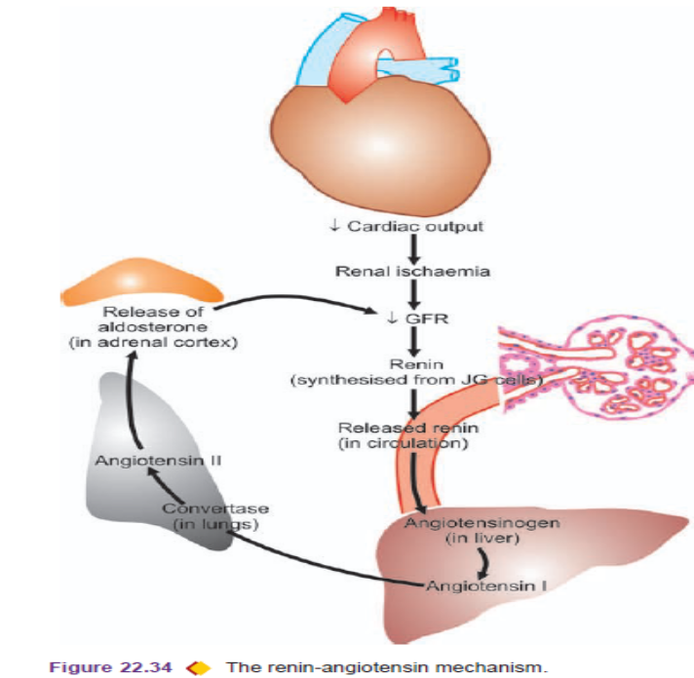
b) Sodium and water retention. Blood volume and cardiac output, both of which have a bearing on blood pressure, are regulated by blood levels of sodium which is significant for maintaining extracellular fluid volume. Blood concentration of sodium is regulated by 3 mechanisms:
i) Release of aldosterone from activation of renin-angiotensin system.
ii) Reduction in GFR due to reduced blood flow as occurs in reduced renal mass or renal artery stenosis. This results in proximal tubular reabsorption of sodium.
iii) Release of atriopeptin hormone from atria of the heart in response to volume expansion. These peptides cause increased GFR and inhibit sodium reabsorption.
c) Release of vasodepressor material. A number of vasodepressor materials and antihypertensives counterbalance the vasopressor effect of angiotensin II. These substances include: prostaglandins (PGE2, PGF2, PGA or medullin) released from interstitial cells of the medulla and platelet-activating factor.
2. ENDOCRINE HYPERTENSION. A number of hormonal secretions may produce secondary hypertension. These are:
i) Adrenal gland—e.g. in primary aldosteronism, Cushing’s syndrome and pheochromocytoma.
ii) Parathyroid gland—e.g. hypercalcaemia in hyperparathyroidism.
iii) Oral contraceptives—Oestrogen component in the oral contraceptives stimulates hepatic synthesis of renin substrate.
3. COARCTATION OF AORTA. causes systolic hypertension in the upper part of the body due to constriction itself. Diastolic hypertension results from changes in circulation.
4. NEUROGENIC. Psychogenic, polyneuritis, increased intracranial pressure and section of spinal cord are uncommon causes of secondary hypertension.

EFFECTS OF HYPERTENSION
Systemic hypertension causes major effects in three main organs—heart and its blood vessels, nervous system, and kidneys. An early clinical marker for renal injury from hypertension and risk factor for cardiovascular disease is macroalbuminuria (i.e. albuminuria > 150 mg/day or random urine albumin/creatinine ratio of >300 mg/gm creatinine), or microalbuminuria estimated by radioimmunoassay.

VEINS
NORMAL STRUCTURE
The structure of normal veins is similar to that of arteries. The walls of the veins are thinner, the three tunicae (intima, media and adventitia) are less clearly demarcated, elastic tissue is scanty and not clearly organised into internal and external elastic laminae. All veins, except vena cavae and common iliac veins, have valves. They prevent retrograde venous blood flow.

VARICOSITIES
Varicosities are abnormally dilated and tortuous veins. The veins of lower extremities are involved most frequently called varicose veins. Veins of other parts of the body which are affected are the lower oesophagus (oesophageal varices), the anal region (haemorrhoids) and the spermatic cord (varicocele).
VARICOSE VEINS
Are permanently dilated and tortuous superficial veins of the lower extremities, especially the long saphenous vein and its tributaries. About 10-12% of the general population develops varicose veins of lower legs, with the peak incidence in 4th and 5th decades of life. Adult females are affected more commonly than the males, especially during pregnancy. This is attributed to venous stasis in the lower legs because of compression on the iliac veins by pregnant uterus.
ETIOPATHOGENESIS
i) Familial weakness of vein walls and valves is the most common cause.
ii) Increased intraluminal pressure due to prolonged upright posture e.g. in nurses, policemen, surgeons etc.
iii) Compression of iliac veins e.g. during pregnancy, intravascular thrombosis, growing tumour etc.
iv) Hormonal effects on smooth muscle.
v) Obesity.
vi) Chronic constipation.
MORPHOLOGIC FEATURES. The affected veins, especially of the lower extremities, are dilated, tortuous, elongated and nodular. Intraluminal thrombosis and valvular deformities are found.
Histologically, there is variable fibromuscular thickening of the wall of the veins due to alternate dilatation and hypertrophy.
EFFECTS. Varicose veins of the legs result in venous stasis which is followed by congestion, oedema, thrombosis, stasis, dermatitis, cellulitis and ulceration. Secondary infection results in chronic varicose ulcers.

PHLEBOTHROMBOSIS AND THROMBOPHLEBITIS
The terms ‘phlebothrombosis’ or thrombus formation in veins, and ‘thrombophlebitis’ or inflammatory changes within the vein wall, are currently used synonymously.
ETIOPATHOGENESIS. Venous thrombosis that precedes thrombophlebitis is initiated by triad of changes: endothelial damage, alteration in the composition of blood and venous stasis. Factors predisposing to these changes are cardiac failure, malignancy, use of oestrogen-containing compounds, postoperative state and immobility due to various reasons.
MORPHOLOGIC FEATURES.Common locations for phlebothrombosis and thrombophlebitis are the deep veins of legs accounting for 90% of cases; termed as deep vein thrombosis (DVT). Other locations are periprostatic venous plexus in males, pelvic veins in the females, and near the foci of infection in the abdominal cavity such as acute appendicitis, peritonitis, acute salpingitis and pelvic abscesses.
Grossly, the affected veins may appear normal or may be distended and firm. A mural or occlusive thrombus is present.
Histologically, the thrombus that is attached to the vein wall induces inflammatory response beginning from the intima and infiltrating into the thrombi, consisting of mononuclear inflammatory cells and fibroblastic proliferation. In late stage, thrombus is either organised or resolved leading to a thick-walled fibrous vein.
EFFECTS. The clinical effects due to phlebothrombosis and thrombophlebitis may be local or systemic.
Local effects are oedema distal to occlusion, heat, swelling, tenderness, redness and pain.
Other systemic manifestations include bacteraemia and septic embolisation to brain, meninges, liver etc.
Special Types of Phlebothrombosis
A few special variants of phlebothrombosis are considered below:
1. THROMBOPHLEBITIS MIGRANS or Trousseau’s syndrome is the term used for multiple venous thrombi that disappear from one site so as to appear at another site. Seen mostly in disseminated visceral cancers (e.g. cancer of lungs, prostate, female reproductive tract, breast, pancreas and gastrointestinal tract).
2. PHLEGMASIA ALBA DOLENS. means‘painful white leg’ refers to extensive swelling of the leg, occurring due to iliofemoral venous thrombosis. It occurs in women during late pregnancy or following delivery when the pregnant uterus causes pressure on the iliofemoral veins, or after extensive pelvic surgery. Development of pulmonary embolism may occur due to involvement of inferior vena cava.
3. PHLEGMASIA CERULEA DOLENS. means ‘painful blue leg’ refers to swollen bluish skin with superficial gangrene. It is a complication of massive iliofemoral venous thrombosis and decreased arterial blood flow.
4. SUPERIOR VENA CAVAL SYNDROME, refers to obstruction of the superior vena cava. The obstruction results from external compression or from thrombosis. Some of the common causes of superior vena caval syndrome are malignancy (especially lung cancer and lymphoma), syphilitic aortic aneurysm and tuberculous mediastinitis. Clinical features include dilated veins of neck and thorax, oedema of the face, neck and upper chest and visual disturbances.
5. INFERIOR VENA CAVAL SYNDROME, is the obstruction of the inferior vena cava resulting from thrombosis by extension from iliofemoral veins. Other causes of obstruction are external compression and neoplastic invasion. Clinical features are oedema of lower extremities, dilated leg veins and collateral venous channels in the lower abdomen
Haemorrhoids (Piles)
Are the varicosities of the haemorrhoidal veins. They are called ‘internal piles’ if dilatation is of superior haemorrhoidal plexus covered over by mucous membrane, and ‘external piles’ if they involve inferior haemorrhoidal plexus covered over by the skin. They are common lesions in elderly and pregnant women. They result from increased venous pressure. Causes include:
1. Portal hypertension
2. Chronic constipation and straining at stool
3. Cardiac failure
4. Venous stasis of pregnancy
5. Hereditary predisposition
6. Tumours of the rectum.
Microscopically, thin-walled and dilated tortuous veins are seen under the rectal mucosa (internal piles) or anal skin (external piles). Secondary changes and complications that may occur include: thrombosis, haemorrhage, inflammation, scarring and strangulation (prolapsed piles).

LYMPHATICS
NORMAL STRUCTURE
Lymphatic capillaries, lymphatic vessels and lymph nodes comprise the lymphatic system. Lymphatic capillaries resemble blood capillaries, and larger lymphatics are identical to veins. Lymphatic capillaries and lymphatics form plexuses around tissues and organs. The walls of lymphatic capillaries are permeable to tissue fluid, proteins and particulate matter.
LYMPHANGITIS
Inflammation of the lymphatics or lymphangitis may be acute or chronic.
Acute lymphangitis occurs in the course of bacterial infections. The most common organisms are (β-haemolytic streptococci and staphylococci). Acute lymphangitis is associated with lymphadenitis.
Grossly, the affected lymphatics are dilated and appear as cutaneous streaks.
Microscopically, the dilated lumen contains acute inflammatory exudate, cell debris and clotted lymph. Acute lymphangitis heals completely.
Chronic lymphangitis occurs due to persistent and recurrent acute lymphangitis or from chronic infections like tuberculosis, syphilis and actinomycosis. Histologically, there is permanent obstruction due to fibrosis of affected lymphatics called chronic lymphoedema.

LYMPHOEDEMA
Lymphoedema is swelling of soft tissues due to localized increase in the quantity of lymph. It may be primary (idiopathic) or secondary (obstructive).
I. PRIMARY (IDIOPATHIC) LYMPHOEDEMA, occurs without underlying secondary cause is called primary or idiopathic lymphoedema. Types include:
1. Congenital lymphoedema 2 subtypes—familial hereditary form (Milroy’s disease) and non-familial (simple) form.
i) Milroy’s disease is a form of congenital and familial oedema affecting one limb and may be more extensive and involve the eyelids and lips.The condition results from developmental defect of lymphatic channels so that the affected tissue shows abnormally dilated lymphatics.
ii) Simple congenital lymphoedema is non-familial form with unknown etiology. It is associated with Turner’s syndrome.
2. Lymphoedema praecox. This is a rare form of lymphoedema affecting young females. Oedema begins in the foot and progresses slowly upwards to involve the whole extremity.The affected area becomes rough and the oedema is non-pitting. The etiology is related to female reproductive system because of aggravation during menses.
II. SECONDARY (OBSTRUCTIVE) LYMPHOEDEMA.
This is more common form of lymphoedema. Causes include:
i) Lymphatic invasion by malignant tumour.
ii) Surgical removal of lymphatics e.g. in radical mastectomy.
iii) Post-irradiation fibrosis.
iv) Parasitic infestations e.g. in filariasis of lymphatics producing elephantiasis.
v) Lymphangitis causing scarring and obstruction.
Obstructive lymphoedema occurs only when the obstruction is widespread collaterals develop. Later there is inflammatory scarring and the lymphatics become fibrosed with enlargement of the affected part. Rupture of dilated large lymphatics may result in escape of milky chyle into the peritoneum (chyloperitoneum), into the pleural cavity (chylothorax), into pericardial cavity (chylopericardium) and into the urinary tract (chyluria).

Lymphangioma: are lymphatic counterparts of vascular angiomas. Lymphangiomas are congenital lesions which are classified as capillary, cavernous and cystic hygroma. Combinations are seen.
CAPILLARY LYMPHANGIOMA is a small, circumscribed, slightly elevated lesion measuring 1 to 2 cm in diameter. The common locations are the skin of head and neck, axilla and mucous membranes.
CAVERNOUS LYMPHANGIOMA. It is more common than the capillary type. The common sites are in the region of head and neck or axilla. A large cystic variety called cystic hygroma occurs in the neck producing gross deformity in the neck.
Histologically, cavernous lymphangioma consists of large dilated lymphatic spaces lined by flattened endothelial cells and containing lymph.
Kaposi’s Sarcoma
Is a malignant angiomatous(mass of blood vessels or lymphatic vessels) tumour, first described by Kaposi, Hungarian dermatologist, in 1872. The tumour has attracted greater attention in the last two decades due to its frequent occurrence in patients with HIV/AIDS.
CLASSIFICATION
1. Classic (European) Kaposi’s sarcoma. This is the form which was first described by Kaposi. It is more common in men over 60 years of age. Eastern European descent. The disease is slow growing and appears as multiple, small, purple, dome-shaped nodules or plaques in the skin, on the legs.
2. African (Endemic) Kaposi’s sarcoma. This form is common in equatorial Africa. It is so common in Uganda that it comprises 9% of all malignant tumours in men. It is found in younger age, especially in boys and in young men and has a more aggressive course than the classic form. The disease begins in the skin but grows rapidly to involve other tissues, especially lymph nodes and the gut.
3. Epidemic (AIDS-associated) Kaposi’s sarcoma. This form is seen in about 30% cases of AIDS, especially in young male homosexuals than the other high-risk groups. The cutaneous lesions are not localised to lower legs but are more extensively distributed involving mucous membranes, lymph nodes and internal organs early in the course of disease.
4. Kaposi’s sarcoma in renal transplant cases. This form is associated with recipients of renal transplants who have been administered immunosuppressive therapy for a long time. The lesions may be localised to the skin or may have widespread systemic involvement.
PATHOGENESIS. It is an opportunistic neoplasm in immunosuppressed patients which has excessive proliferation of spindle cells of vascular origin having features of both endothelium and smooth muscle cells: Epidemiological studies have suggested a viral association implicating HIV and human herpesvirus 8. Occurrence of Kaposi’s sarcoma involves interplay of HIV-1 infection, HHV-8 infection, activation of the immune system and secretion of cytokines (IL-6, TNF, GM-CSF(granulocyte-macrophage colony-stimulating factor), basic fibroblast factor, and oncostain M). Defective immunoregulation plays a role in its pathogenesis substantiated by observation of second malignancy (e.g. leukaemia, lymphoma and myeloma) in about one-third of patients with Kaposi’s sarcoma.
MORPHOLOGIC FEATURES. Grossly, the lesions in the skin, gut and other organs form prominent, irregular, purple, dome-shaped plaques or nodules. Histologically, the changes are nonspecific in the early patch stage and more characteristic in the late nodular stage.
Early patch stage: There are irregular vascular spaces separated by interstitial inflammatory cells and
extravasated blood and haemosiderin. Late nodular stage: There are slit-like vascular spaces containing red blood cells and separated by spindleshaped, tumour cells.
CLINICAL COURSE. The clinical course and biologic behaviour of Kaposi’s sarcoma is variable. The classic form of Kaposi’s sarcoma is confined to skin and the course is slow with long survival. The endemic (African) and epidemic (AIDS-associated) Kaposi’s sarcoma, has a rapidly progressive course, with widespread cutaneous visceral involvement, and high mortality.

